**Supplementary Data**

**Comparative transcriptomics elucidates adaptive phenol tolerance and utilization in lipid-accumulating *Rhodococcus opacus* PD630**

Aki Yoneda, William R. Henson, Nicholas K. Goldner, Kun Joo Park,  Kevin J. Forsberg, Soo Ji Kim, Mitchell W. Pesesky, Marcus Foston, Gautam Dantas and Tae Seok Moon

**Supplementary Materials and Methods**

**Chemicals, strains, and growth conditions**

All chemicals for growth experiments were purchased from Sigma Aldrich (St. Louis, MO). *Rhodococcus opacus* PD630 (DSMZ 44193) was used as the parental strain (WT) for comparison to all mutated strains. Cultures were grown in a New Brunswick Innova 44R shaking incubator at 30°C at 250 rpm. For all experiments, *R. opacus* PD630 was grown in a defined minimal salts medium (MSM) containing 9.00 g Na2HPO4·12H2O, 1.50 g KH2PO4, 0.20 g MgSO4·7H2O, 1.2 mg FeNH4 citrate, 20 mg CaCl2, 2 mL Hoagland solution, and 0.50 g NaHCO3 per liter of distilled water. The nitrogen source was 1 g/L (NH4)2SO4 unless otherwise noted. Both nitrogen and carbon sources were added from filter-sterilized stock solutions. Culture media were filter-sterilized using a 0.22 μm filter. Strains were maintained on LB agar plates by streaking.

For RNA-Seq experiments, single colonies from LB agar plates were grown in 2 mL of 0.3 g/L phenol in minimal media for 48 hours in a 50 mL glass culture tube. The 2 mL of cell culture was then added to 10 mL of 0.3 g/L phenol minimal media in a 50 mL glass culture tube for 24 hours, and then subcultured again in 100 mL of 0.3 g/L in a 250 mL baffled flask for 24 hours. The final subculture for each experiment was 150 mL of 0.3 g/L phenol in a 250 mL baffled flask for 24 hours. In the final step, the cells were centrifuged at 3000 x g for 10 minutes, then re-suspended in carbon- and nitrogen-free minimal media, and added to 250 mL baffled flasks with 100 mL of minimal medium containing 1 g/L glucose, 0.75 g/L phenol, or 1.5 g/L phenol supplemented with 0.05 g/L (NH4)2SO4 at an initial optical density (OD600) of 0.3. Cultures were harvested at late exponential/early stationary phase (OD600 ~1 for all cultures). The WT strain did not show significant growth in 1.5 g/L phenol when grown in such large volumes of media (10 mL or larger).

Growth assays were performed by culturing single colonies from LB agar plates in 2 mL of minimal medium supplemented with 0.3 g/L phenol as the sole carbon source in a 50 mL glass tube. After 36-48 hours, the 2 mL of cell culture was added to 10 mL of 0.3 g/L phenol minimal media and subcultured for an additional 24 hours. Cells were centrifuged at 2000 x g for 5 min, resuspended in carbon-free media, and added to 96-well plates (Chimney well F-bottom, REF-655096, Grenier Bio-One) to an initial OD600 of 0.01 with a total volume of 200 μL unless otherwise indicated. Carbon sources were added from concentrated stock solutions. Absorbance measurements (at 600 nm) were performed on a TECAN Infinite M200 Pro plate reader for 45 hours, and OD600 values were obtained by multiplying 1.975, the experimentally determined conversion factor (OD600 = 1.975 x Absorbance600 from the Tecan value; R2 = 1.00). Specific growth rates were calculated by fitting optical density measurements in the log phase. Lag phase was calculated as the time for more than two doublings to occur (OD600 > 0.04). IC50 values were calculated in Prism (GraphPad Software, Inc.) using a four parameter inhibitor response curve from OD600 measurements made at different time points.

**RNA and DNA isolation**

75 mL of *R. opacus* liquid cultures were harvested by centrifugation and stored in 3 mL of RNAShield (Zymo Research) for 30 minutes at room temperature, and then stored at 4ºC until all samples were harvested and stored. RNA-stabilized cells were divided into three tubes, and centrifuged again to remove RNAShield. The cells from one set containing all 24 samples (eight strain:conditions, biological triplicates; Supplementary Figure S1) were used to isolate total RNA, while the rest were stored at -80ºC as backup samples.

Total RNA was isolated using a ZR Fungal/Bacterial RNA MiniPrep kit (Zymo Research) following the manufacturer’s protocol with a version that removes most of small RNAs. The total RNA was treated with TURBO DNase I (Ambion) for 30 minutes at 37ºC (6U enzyme up to 6 µg of total RNA). After DNase I treatment, total RNA samples were cleaned using an RNA Clean & Concentrator kit (Zymo Research) and eluted in 20 µL of nuclease free water. Total RNA was checked by PCR to confirm the absence of contaminating genomic DNA and quantified using a Qubit RNA-HS kit (Invitrogen) after appropriate dilutions.

Genomic DNA was isolated from identical samples used for RNA-Seq. A standard bead beating-phenol-chloroform isolation method was used to isolate genomic DNA. RNaseA-treated and purified genomic DNA was quantified using a Qubit DNA BR kit.

**rRNA depletion from *R. opacus* total RNA**

5 µg of DNase I-treated, cleaned total RNA of each sample was used to deplete ribosomal RNA using a RiboZero rRNA Removal Kit Bacteria (Epicentre, currently Illumina). Ribosomal RNA was depleted according to the manufacturer’s protocol, except for a minor modification: for the rRNA probe-RNA sample hybridization step at room temperature, samples were vigorously mixed by vortexing every 2 minutes for 10 minutes, and a 50ºC incubation was changed to a 52ºC incubation for 10 minutes, with vortexing every 2 minutes. After rRNA depletion, samples were cleaned using RNAClean XP beads (Agencourt). Aside from quality and quantity checking, all of rRNA-depleted RNA samples were used to generate cDNA. First strand cDNA was synthesized using 1 µL PrimeScript (Clontech), 1 µL 10mM dNTP mix (67% GC), 0.5 µL Random Primers (3 µg/mL, Invitrogen), 4 µL 5x PrimeScript buffer, and 1 µL RNase inhibitor (included in RiboZero kits) at 24ºC for 10 minutes, 42ºC for 50 minutes, and 70ºC for 15 minutes. Second strand synthesis mix (61.75 µL nuclease-free water, 10 µL NEBuffer 2, 3 µL 10 mM dNTP mix, 5 µL *E. coli* DNA polymerase I (NEB), 0.25 µL RNase H (NEB)) was added to the first strand cDNA and incubated for 2 hours at 16ºC. 1 µL *E. coli* DNA ligase was added to each reaction and the samples were incubated at 16ºC for another 15 minutes before clean-up using a Qiagen PCR purification kit. Double-stranded cDNA was quantified using a Qubit DNA HS kit, and 50 µL of the eluate containing all cDNA was used to generate the Illumina library.

**Microscopy**

For fluorescence microscopy, *R. opacus* cells were stained as described previously (MacEachran et al, 2010)*.* Stained cells on prepared slides were observed using Axioskop 2 MOT Plus microscope (Carl Zeiss, Inc.). Images were acquired with an AxioCam MRm camera (Carl Zeiss, Inc.) using Axiovison software. For transmission electron microscopy, *R. opacus* cells were fixed for 2 hours at room temperature in 2% paraformaldehyde/2.5% glutaraldehyde (Polysciences Inc.) in 100 mM cacodylate buffer (pH 7.2). Samples were washed in cacodylate buffer and postfixed in 1% osmium tetroxide (Polysciences Inc.) for 1 hour. Samples were then rinsed extensively in dH2O prior to en bloc staining with 1% aqueous uranyl acetate (Ted Pella Inc.) for 1 hour. Following several rinses in dH2O, samples were dehydrated in a graded series of ethanol and embedded in Eponate 12 resin (Ted Pella Inc.). Sections of 95 nm were cut with a Leica Ultracut UCT ultramicrotome (Leica Microsystems Inc.,), stained with uranyl acetate and lead citrate, and viewed on a JEOL 1200 EX transmission electron microscope (JEOL USA Inc.) equipped with an AMT 8 megapixel digital camera (Advanced Microscopy Techniques).

**Lipid quantification using the Folch method**

Cellular lipids were extracted using the Folch method (Folch et al, 1957) with some modifications. Briefly, 100 mL of cell culture was pelleted at 4600g for 15 minutes, washed twice with 0.1% ammonium acetate, and lyophilized overnight. ~10 mg of lyophilized biomass was resuspended in 2 mL of a 2:1 chloroform:methanol solution with glass beads and vortexed for 20 minutes. Next, 400 L of 0.9% NaCl was added to induce phase separation and the mixture was incubated at room temperature for 15 minutes. The organic phase was removed and extracted twice to eliminate carryover from the aqueous phase. Samples were weighed after drying overnight at 60°C to determine total lipid content (% CDW lipid; CDW, cell dry weight).

**Measurement of phenol concentrations in culture media**

To estimate the concentration of phenol in cell cultures over time (Supplementary Figure S3), 1 mL aliquots of cell culture were centrifuged at 16,000g for 5 min, and 100 L of supernatant was diluted 10-fold in minimal medium with no carbon source and stored at –20°C until measurement. Absorbance at 280 nm was measured in a quartz cuvette using a Nanodrop 2000c spectrophotometer (Thermo Fisher Scientific, USA) and correlated to phenol concentration by comparing the absorbance value at 280 nm with that of a standard curve which was obtained by using known concentrations of phenol in minimal medium without cells (Supplementary Figure S15).

**Supplementary Computational Methods.**

**Rpkm values were calculated using a standard method.**

C = Number of reads mapped to a gene

N = Total mapped reads in the experiment

L = gene length (base-pairs)

Equation = RPKM = (10^9 \* C)/(N \* L)

code in R

for(i in 1:length(Ro\_CAS\_samplenames)) {

for(k in 1:length(Ro\_CAS\_genenames))

{Ro\_CAS\_rpkm[k, i]<-(Ro\_CAS\_rawcounts\_mod[Ro\_CAS\_genenames[k],Ro\_CAS\_samplenames[i]]/(Ro\_CAS\_rawcounts\_mod[Ro\_CAS\_genenames[k], "Length"]\*Ro\_CAS\_sumcounts[Ro\_CAS\_samplenames[i]]))\*10^9}

}

**An in-house Python script to filter out SNPs found in WT**

It was initially used to look at upregulated genes, but after re-sequencing the strains we used AllGeneFile instead of <InterestingGeneFile>.

#! /usr/bin/env python

from \_\_future\_\_ import division #So division isn't automatically floored to the integer

if \_\_name\_\_ == '\_\_main\_\_':

import sys

import os

import subprocess

cwd = os.getcwd()#current working directory

usage = "SummarizePilonSNPs.py <InterestingGeneFile> <\_\_transcripts.gtf> <\_\_genes.fasta> <WT\_SNPfile.vcf> <SNPfile.vcf>"

args = sys.argv[2:]

if args:

for i in range(5):

try:

sys.argv[i]

except IndexError:

print "".format(usage)

else:

sys.exit(usage)

def run(cmd):

p = subprocess.Popen(cmd, shell=True, stdout=subprocess.PIPE)

p.wait()

out, errs = p.communicate()

return [out, errs]

###Variables###

allGenes = []

interestingGenes = []

geneInfo = {}

geneIndex = -1

wtSNPs = []

goi\_noWT = []

snpID = 0

duplicatedGOIs = []

interestingGeneFile = open(sys.argv[1], "r")

for line in interestingGeneFile:

if line[0] != "\n":

line = line.rstrip('\n')#chomps line

table = line.split('\",\"')

if table[1][0] != "x":

interestingGenes.append(table[1][:-1])

interestingGeneFile.close()

transcriptFile = open(sys.argv[2], "r")

for line in transcriptFile:

if line[0] != '\n':

line = line.rstrip('\n')#chomps line

table = line.split('\t')

if table[2] == "exon":

contig\_beg\_end = []

annotTable = table[8].split('\"; transcript\_id')

geneName = annotTable[0][9:]

allGenes.append(geneName)

contig\_beg\_end = [table[0],int(table[3]),int(table[4])]

geneInfo[geneName] = contig\_beg\_end

transcriptFile.close()

genesFile = open(sys.argv[3], "r")

for line in genesFile:

if line[0] != '\n':

line = line.rstrip('\n')#chomps line

if line [0] == ">":

geneIndex += 1

infoList = geneInfo[allGenes[geneIndex]]

table = line.split(' | ')

annotTable = table[1].split()

del annotTable[-2:]

del annotTable[0:3]

annotation = " ".join(annotTable)

infoList.append(annotation)

geneInfo[allGenes[geneIndex]] = infoList

genesFile.close()

#print "Gene Name\tContig\tStart\tStop\tAnnotation"

#for geneName in allGenes:

#infoList = geneInfo[geneName]

#print "{}\t{}\t{}\t{}\t{}".format(geneName,infoList[0],infoList[1],infoList[2],infoList[3])

wtSNPfile = open(sys.argv[4], "r")

for line in wtSNPfile:

if line[0] != '\n':

line = line.rstrip('\n')#chomps line

if line[0] != "#":

table = line.split()

contig = table[0]

pos = int(table[1])

reference = table[3]

variant = table[4]

quality = table[5]

if variant[1:4] == "DUP":

details = table[7]

detailTable = details.split(";")

dupStop = int(detailTable[2][4:])

for goi in interestingGenes:

infoList = geneInfo[goi]

if (infoList[0] == contig):

if ((infoList[2] >= pos) and (infoList[1] <= dupStop)):

pass

else:

goi\_noWT.append(goi)

else:

currSNP = contig + "\_" + str(pos) + "\_" + reference + "\_" + variant

wtSNPs.append(currSNP)

wtSNPfile.close()

print "SNP-id\tContig\tPosition\tReference\tVariant\tQuality\tDepth\tVariant Frequency\tAnnotation"

exptSNPfile = open(sys.argv[5], "r")

for line in exptSNPfile:

if line[0] != '\n':

line = line.rstrip('\n')#chomps line

if line[0] != "#":

snpAnnotation = "NON-CODING"

table = line.split()

contig = table[0]

pos = int(table[1])

reference = table[3]

variant = table[4]

quality = table[5]

details = table[7]

detailTable = details.split(";")

if variant[1:4] == "DUP":

dupStop = int(detailTable[2][4:])

for goi in goi\_noWT:

infoList = geneInfo[goi]

if (infoList[0] == contig):

if ((infoList[2] >= pos) and (infoList[1] <= dupStop)):

if goi in duplicatedGOIs:

pass

else:

duplicatedGOIs.append(goi)

else:

keep = 1

if detailTable[0][0:3] == "DP=":

depth = int(detailTable[0][3:])

frequency = detailTable[12][3:]

else:

depth = detailTable[0][7:]

delEnd = detailTable[2][4:]

delLen = detailTable[1][7:]

frequency = "One deletion of length " + delLen + " from position " + str(pos) + " to " + delEnd

currSNP = contig + "\_" + str(pos) + "\_" + reference + "\_" + variant

for wtSNP in wtSNPs:

if currSNP == wtSNP:

keep = 0

break

if keep == 1:

snpID +=1

for geneName in allGenes:

infoList = geneInfo[geneName]

if contig == infoList[0]:

if ((pos >= infoList[1]) and (pos <= infoList[2])):

snpAnnotation = geneName + ": " + infoList[3]

break

else:

if (((pos >= (infoList[1] - 100)) and (pos < infoList[1])) or ((pos <= (infoList[2] + 100)) and (pos > infoList[2]))):

if snpAnnotation == "NON-CODING":

snpAnnotation = "Within 100bp of the following gene(s)--- " + geneName + ": " + infoList[3]

elif snpAnnotation[0:34] == "Within 100bp of the following gene":

snpAnnotation = snpAnnotation + "; " + geneName + ": " + infoList[3]

print "{}\t{}\t{}\t{}\t{}\t{}\t{}\t{}\t{}".format(snpID,contig,pos,reference,variant,quality,depth,frequency,snpAnnotation)

exptSNPfile.close()

print"\n\n##############~~~~The following genes may be within putatively duplicated regions~~~~###################\n\n"

for goi in duplicatedGOIs:

infoList = geneInfo[goi]

print "{}\t{}".format(goi,infoList[3])

**Supplementary Figures**

**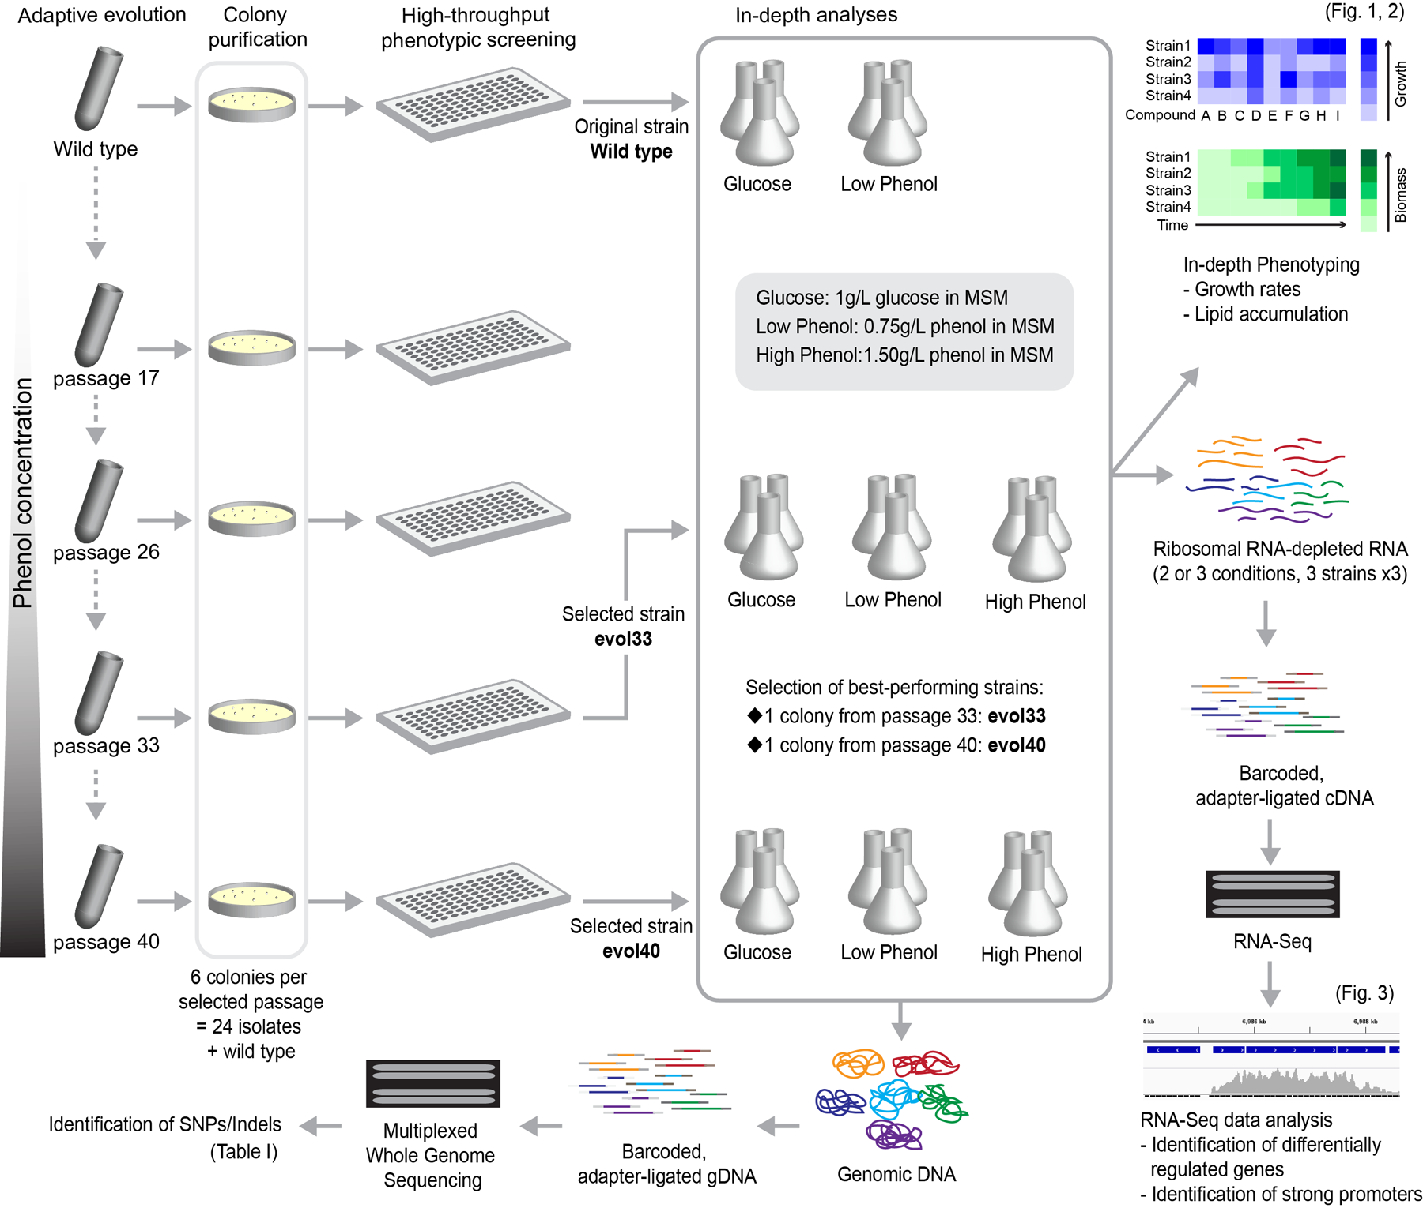**

**Supplementary Figure S1. Experimental approach.** *R. opacus* PD630 wild-type (WT) strain was passaged in a minimal salts medium (MSM) with increasing concentrations of phenol as a sole carbon source, and an aliquot of the liquid culture was taken and stored at -80ºC at each passage. Of the 40 passages, 6 colonies per passage were purified from passages 17, 26, 33, and 40. Growth and lipid accumulation profiles of the isolated strains were analyzed, and two top performing colonies, evol33 and evol40, were chosen. WT, evol33, and evol40 were further analyzed by whole genome sequencing (Table 1), RNA-Seq (Table 2 and Figure 3), and in-depth phenotyping including determination of growth profiles on different concentrations of phenol (Figure 1) and total lipid productivity (Figure 2).





|  |  |  |  |  |  |
| --- | --- | --- | --- | --- | --- |
|  | **WT** | **evol33** | **evol40** | **evol33 improvement (%)** | **evol40 improvement (%)** |
| 24 hr IC50 (g/L) | 1.29 ± 0.10 | 1.49 ± 0.19 | 1.44 ± 0.11 | 15.5 | 11.6 |
| 45 hr IC50 (g/L) | 1.58 ± 0.08 | 1.90 ± 0.05 | 1.96 ± 0.06 | 20.3 | 24.1 |

**Supplementary Figure S2. Characterization of IC50 values for WT and adapted strains**. Optical densities (OD600) measured from cultures grown in various concentrations of phenol and high nitrogen (1 g/L ammonium sulfate) at 24 and 45 hours were fitted in Prism using a four-parameter inhibitor response curve to calculate the IC50 values. R2 values were greater than 0.88 for all fittings. The fitted values for each biological replicate were averaged to calculate p values for significance (one mean, two-tailed Student’s *t*-test). IC50 values at 24 hours are not significantly different from WT for both adapted strains (p = 0.07 and p = 0.06 for evol33 and evol40, respectively), but IC50 values for both evol33 and evol40 at 45 hours are significantly higher than that of WT (p = 0.0004 and p = 0.0002 for evol33 and evol40, respectively). Error represents one standard deviation of fitted values from six biological replicates grown in 96 well plates. Improvement was calculated as (evolXIC50-WTIC50) / WTIC50 x 100%, where X = 33 or 40.

****

**Supplemental Figure S3. Growth and phenol consumption profiles of WT and adapted strains.** Cells were grown in 100 mL of high nitrogen (1 g/L) minimal salts medium containing 1.5 g/L phenol as the sole carbon source. White diamonds = WT, gray squares = evol33, black triangles = evol40, and black square with white cross = no cell control (1.5 g/L phenol). **A**, Growth profile of WT and adapted strains. **B**, Phenol consumption profiles of WT and adapted strains. Phenol (g/L) was estimated by measuring absorbance of culture supernatants at 280 nm (see the Supplementary Materials and Methods). For both plots, each point is the average of three biological replicates and the error bars represent one standard deviation of three biological replicates.

**Supplementary Figure S4. Correlation between Nile red fluorescence and total lipid content (% CDW lipid).** The WT strain was grown in four different ammonium sulfate concentrations (1, 0.2, 0.1, and 0.025 g/L) as a sole nitrogen source and 1 g/L glucose as a sole carbon source for 24 hours. Three 200 L aliquots of each biological replicate were used for Nile red fluorescence measurement. Cells from each biological replicate were lyophilized, and the cell dry weight lipid content (% CDW lipid) of each biomass sample was calculated from the total lipids extracted using the Folch procedure (See Materials and Methods). The Nile red fluorescence values represent the average of three technical replicates from two biological replicates for a total of six replicates. The % CDW lipid values are the average of two biological replicates. The error bars represent the standard error.



**Supplemental Figure S5. Nile red fluorescence and growth kinetics of WT and adapted strains**. The top row shows the growth profile of each strain in low nitrogen conditions (0.05 g/L ammonium sulfate), and the bottom row shows the average Nile red fluorescence of each strain over time. No growth was observed for the WT strain in 1.5 g/L phenol with low nitrogen (<1 cell doubling in 10 mL cultures). Each data point represents the average of three biological replicates. Each Nile red fluorescence value is the arithmetic mean of the Nile red fluorescence distribution obtained using flow cytometry (see Materials and Methods for more information). Error bars represent one standard deviation.



**Supplementary Figure S6. Lipid accumulation using lignin model compounds.** Cultures were grown in 96 well plates at 200 L volumes in low nitrogen (0.05 g/L) minimal medium using 1 g/L of total phenolics as a carbon source. Cells were harvested after 48 hours and analyzed for lipid content by Nile red analysis (see Materials and Methods). HBA = 4-hydroxybenzoic acid, Benz = sodium benzoate, P+HBA+Benz = 1 g/L total phenolics; 0.33 g/L phenol, 0.33 g/L HBA, and 0.33 g/L Benz. e33 = evol33 and e40 = evol40. Stars represent significantly higher lipid accumulation compared to WT (p < 0.05, one tailed Student’s t-test). evol33 and evol40 show significantly higher lipid accumulation in phenol compared to WT (p = 0.009 for evol33, p = 0.005 for evol40). However, the adapted strains do not show increased lipid production, compared to that of WT, on other lignin model compounds, although all strains have higher lipid accumulation using hydroxybenzoic acid and sodium benzoate as carbon sources than using phenol (p < 0.04 for all cases). Bars represent the average of five biological replicates, and error bars represent one standard deviation.

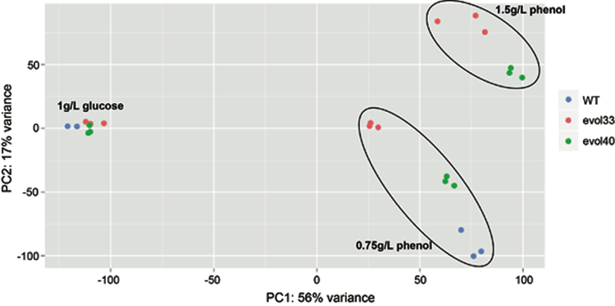

**Supplementary Figure S7.** Principal component analysis plot of all 8945 genes from RNA-Seq triplicate samples, generated by using the plotPCA function of DESeq2. Blue, WT; pink, evol33; green, evol40. Medium conditions are indicated in the plot.

**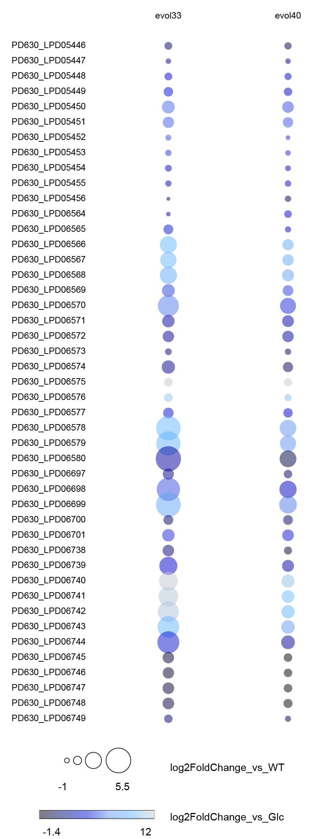**

**Supplementary Figure S8.** Bubble plot representation of fold changes in phenol degradation and utilization genes in low phenol (0.75 g/L). Sizes of the bubbles indicate log2 fold change compared to the same medium condition in WT, and colors indicate log2 fold change compared to the indicated adapted strain in glucose (1 g/L).

Ro_CAS_altphepathways_v3.tif

**Supplementary Figure S9. Expression profiles of other annotated phenolic degradation genes.** Heat map of genes annotated as alternative phenol degradation pathways by RhodoCyc (http://rhodocyc.broadinstitute.org/) is shown. LPD gene IDs were converted from OPAG gene IDs using NCBI BLAST. Glc, 1 g/L glucose; LowP, 0.75 g/L phenol; and HighP, 1.5 g/L phenol.

****

**Supplementary Figure S10. Phenolic degradation pathways present in *R. opacus* PD630.** Each enzymatic reaction is listed as a number that can be found inSupplementary Table S8 with enzyme name, E.C. number, and Gene ID number(s). Dotted lines represent alternate aromatic degradation pathways that could be involved in phenol degradation. **A**, Gentisate degradation pathway. **B**, Protocatechuate *ortho*-cleavage branch of -ketoadipate pathway. **C**, Catechol *ortho*-cleavage branch of -ketoadipate pathway. **D**, Catechol *meta*-cleavage branch of -ketoadipate pathway.Pathway information shown was matched to the KEGG database (Kanehisa & Goto, 2000).

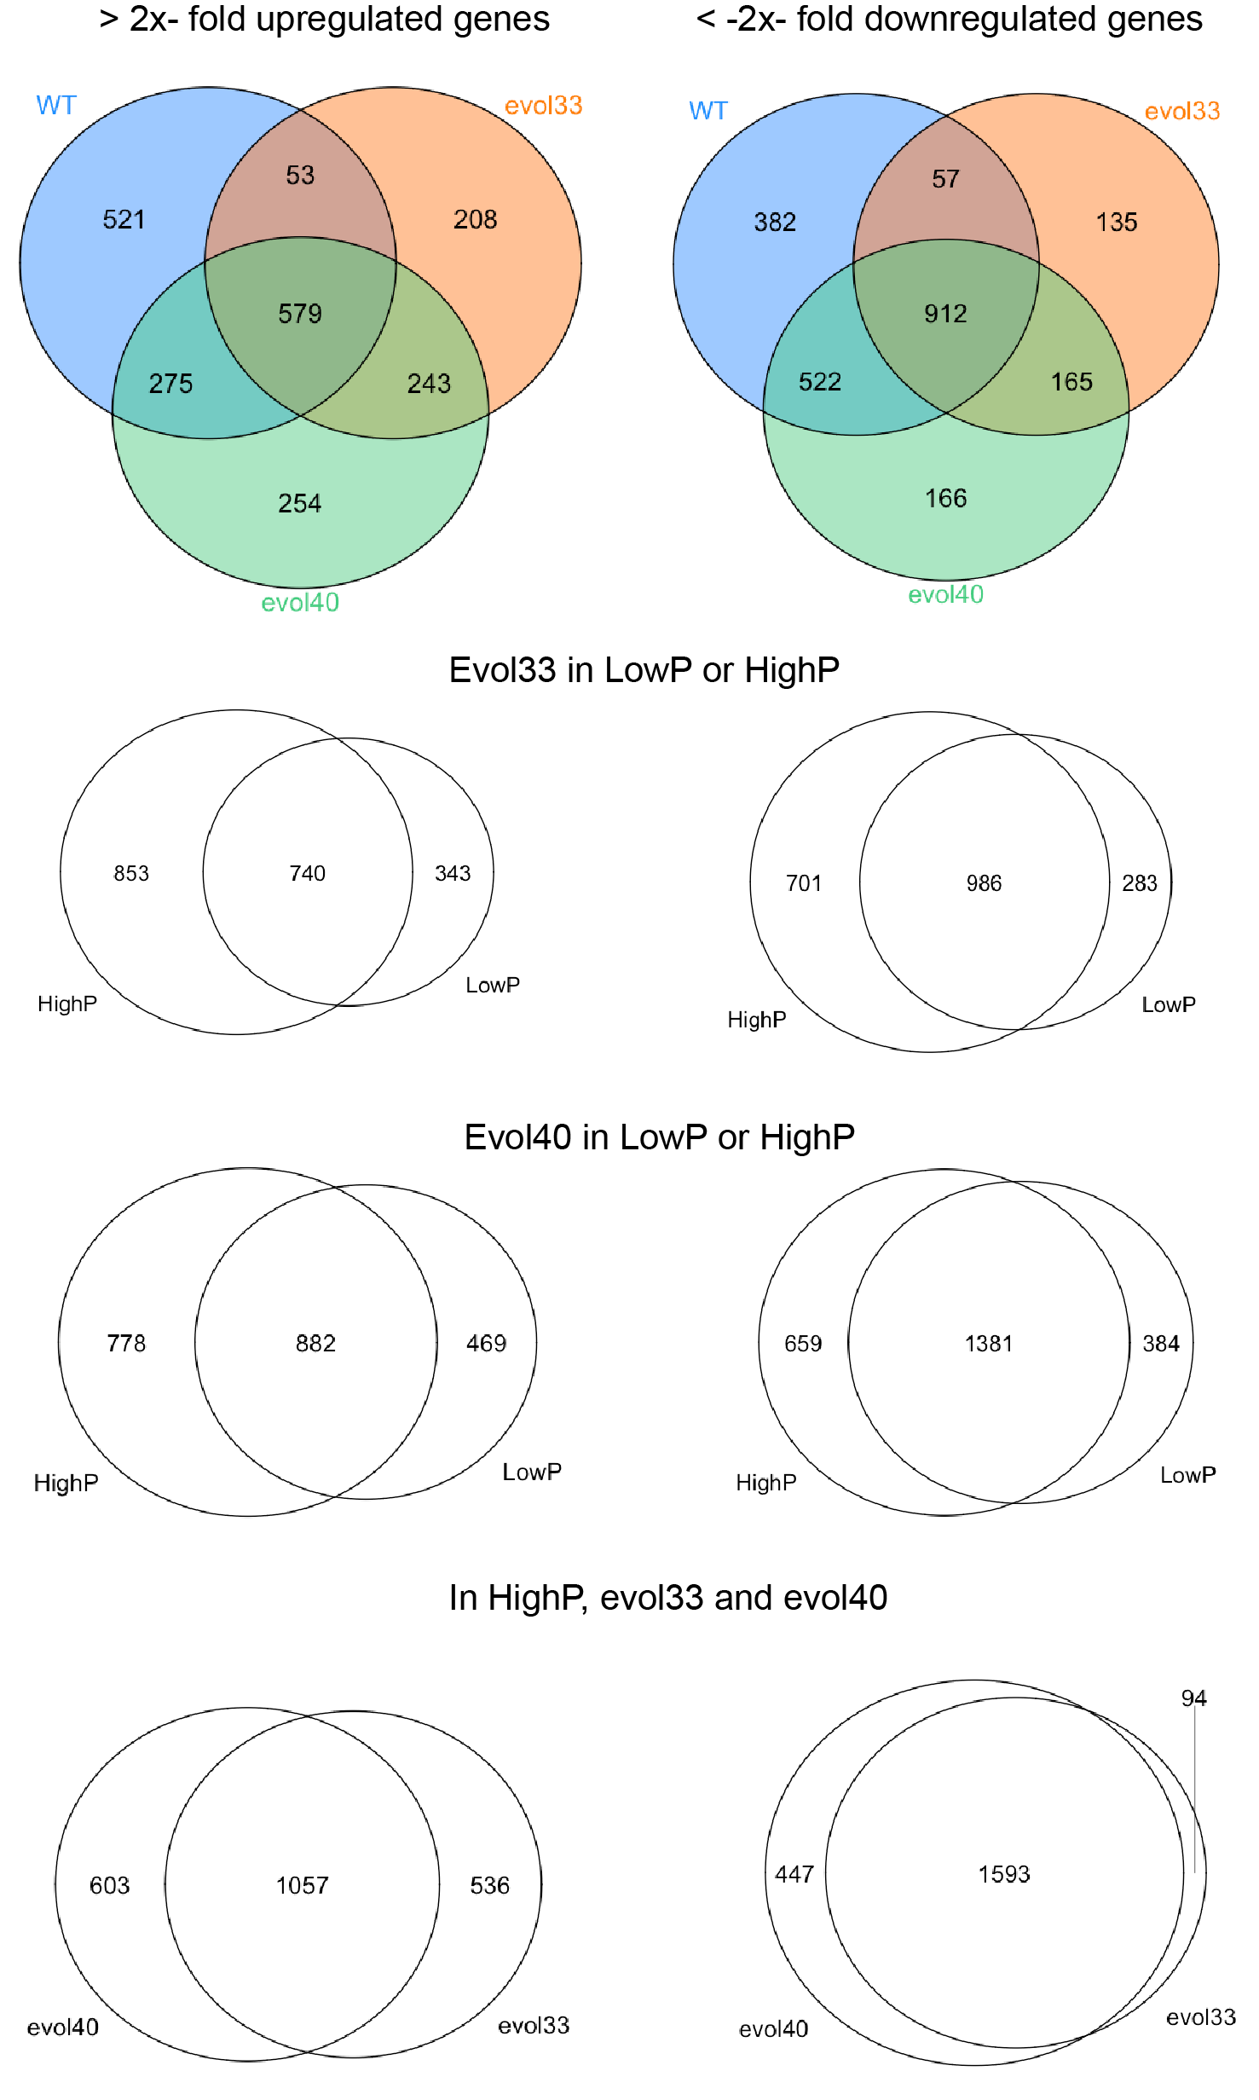

**Supplementary Figure S11.** Venn diagrams of genes >2-fold upregulated and < -2-fold downregulated in phenol in WT, evol33, and evol40 (padj < 0.01). Glucose vs. low phenol conditions were compared for all 3 strains; genes with > |2|-fold changes in low phenol (0.75 g/L, LowP) and high phenol (1.5 g/L, HighP) compared to glucose are shown in the same strains. > |2|-fold upregulated and downregulated genes in HighP in evol33 and evol40 are also shown. All genes have adjusted p values of < 0.01.

FigS_microscopy.tif

**Supplementary Figure S12. Microscopy images of *R. opacus* PD630 under nitrogen-limited conditions.** Theleft four columns are epifluorescence micrographs of Nile red-stained, stationary phase *R. opacus* PD630 cells grown in nitrogen-limited conditions. The far right column shows transmission electron micrographs of *R. opacus* cells grown in the same conditions.

MAplots_summary_Ro_v2.tif

**Supplementary Figure S13. MA Plot Summary.** Each panel shows the up- or down-regulation of all genes in an indicated strain and medium composition compared to a different strain and medium composition. Expression difference of each gene is plotted as log2 fold change (y axis) and mean expression (x axis) of the gene. The gray dots represent insignificant fold changes in expression, and the red dots represent significant fold changes in expression where significance threshold is defined as the adjusted *p* value < 0.1 (false discovery rate (Benjamini-Hochberg procedure) calculated using DESeq2 (Love et al, 2014). Glc, 1 g/L glucose; LowP, 0.75 g/L phenol; and HighP, 1.5 g/L phenol.

FigS_Rsr_YRNA.tif

**Supplementary Figure S14. Expression profile of Rsr and YRNA homologs in different growth conditions. Top**,Rsr homolog expression profile. Raw counts were normalized using the plotCounts function in DESeq2 (Love et al, 2014) and plotted using Beeswarm package (https://cran.r-project.org/web/packages/beeswarm/index.html). **Bottom**, RNA reads mapped to the noncoding region upstream of LPD06269 (predicted YRNA). Glc, 1 g/L glucose; LowP, 0.75 g/L phenol; and HighP, 1.5 g/L phenol.

**Supplementary Figure S15. Calibration curve obtained by using known concentrations of phenol in minimal medium and measuring absorbance at 280 nm.**

**Supplementary Tables**

**Supplementary Table S1.** **Comparison of WT, evol33, and evol40 maximum biomass accumulation.** Initial OD600 was 0.01, and cells were grown in high nitrogen conditions (1 g/L ammonium sulfate). Biomass accumulation values reported are the highest attained OD600 value after 45 hours of growth. Significance was determined by a one mean, two-tailed Student’s t-test (p < 0.05). Error represents one standard deviation of six biological replicates grown in 96 well plates. Improvement was calculated as (evolX-WT) / WT x 100%, where X = 33 or 40. See Materials and Methods for more details.

|  |  |  |  |  |  |  |
| --- | --- | --- | --- | --- | --- | --- |
| **Phenol (g/L)** | **WT**  **(OD600)** | **evol33**  **(OD600)** | **evol40**  **(OD600)** | **Significantly higher than WT?** | **evol33 improvement (%)** | **evol40 improvement (%)** |
| 0.75 | 0.33 ± 0.03 | 0.45 ± 0.03 | 0.44 ± 0.04 | Yes, both | 36.1 | 32.5 |
| 1 | 0.40 ± 0.06 | 0.48 ± 0.05 | 0.48 ± 0.04 | Yes, both | 21.5 | 22.0 |
| 1.25 | 0.39 ± 0.07 | 0.52 ± 0.05 | 0.53 ± 0.05 | Yes, both | 32.2 | 33.4 |
| 1.5 | 0.27 ± 0.04 | 0.52 ± 0.06 | 0.55 ± 0.06 | Yes, both | 92.3 | 102.4 |
| 1.75 | 0.18 ± 0.05 | 0.35 ± 0.04 | 0.44 ± 0.03 | Yes, both | 92.3 | 145.9 |
| 2 | 0.07 ± 0.04 | 0.27 ± 0.04 | 0.32 ± 0.03 | Yes, both | 297.6 | 372.5 |

**Supplementary Table S2. Comparison of WT, evol33, and evol40 lag phase.** Initial OD600 was 0.01, and cells were grown in high nitrogen conditions (1 g/L ammonium sulfate). Lag phase was calculated as the time for more than two doublings to occur (OD600 > 0.04). Significance was determined by a one mean, two-tailed Student’s t-test (p < 0.05). Error represents one standard deviation of six biological replicates grown in 96 well plates. Improvement was calculated as (WT-evolX) / WT x 100%, where X = 33 or 40. See Materials and Methods for more details.

|  |  |  |  |  |  |  |
| --- | --- | --- | --- | --- | --- | --- |
| **Phenol (g/L)** | **WT**  **(h)** | **evol33**  **(h)** | **evol40**  **(h)** | **Significantly lower than WT?** | **evol33 improvement (%)** | **evol40 improvement (%)** |
| 0.75 | 4.7 ± 2.4 | 3.3 ± 1.3 | 3.8 ± 0.1 | No | 28.4 | 18.2 |
| 1 | 7.9 ± 5.7 | 6.6 ± 5.1 | 3.8 ± 0.1 | No | 17.3 | 51.9 |
| 1.25 | 10.7 ± 5.7 | 7.2 ± 6.4 | 6.6 ± 5.1 | No | 32.6 | 38.6 |
| 1.5 | 17.3 ± 2.7 | 9.3 ± 5.9 | 11.5 ± 5.0 | Evol33 only | 46.4 | 33.6 |
| 1.75 | 25.4 ± 4.3 | 14.2 ± 5.2 | 12.0 ± 5.1 | Yes, both | 44.3 | 52.6 |
| 2 | 39.9 ± 5.7 | 18.4 ± 3.2 | 18.4 ± 3.2 | Yes, both | 53.9 | 53.9 |

**Supplementary Table S3.** **Comparison of WT, evol33, and evol40 growth rates.** Initial OD600 was 0.01, and cells were grown in high nitrogen conditions (1 g/L ammonium sulfate). Specific growth rates were calculated from fitting optical density measurements in the exponential phase. Significance was determined by a one mean, two-tailed Student’s t-test (p < 0.05). Error represents one standard deviation of six biological replicates grown in 96 well plates. The fitted values for each biological replicate were averaged to calculate p values for significance. N/A = not applicable. \* = not enough growth to calculate accurate growth rate. Improvement was calculated as (evolX-WT) / WT x 100%, where X = 33 or 40. See Materials and Methods for more details.

|  |  |  |  |  |  |  |
| --- | --- | --- | --- | --- | --- | --- |
| **Phenol (g/L)** | **WT**  **(hr-1)** | **evol33**  **(hr-1)** | **evol40**  **(hr-1)** | **Significantly higher than WT?** | **evol33 improvement (%)** | **evol40 improvement (%)** |
| 0.75 | 0.06 ± 0.01 | 0.08 ± 0.03 | 0.07 ± 0.01 | No | 27.6 | 9.7 |
| 1 | 0.09 ± 0.02 | 0.12 ± 0.01 | 0.11 ± 0.02 | evol33 only | 27.7 | 12.8 |
| 1.25 | 0.08 ± 0.02 | 0.11 ± 0.02 | 0.12 ± 0.03 | Yes, both | 39.3 | 48.6 |
| 1.5 | 0.07 ± 0.01 | 0.09 ± 0.01 | 0.10 ± 0.02 | Yes, both | 29.6 | 37.7 |
| 1.75 | 0.08 ± 0.01 | 0.09 ± 0.01 | 0.09 ± 0.01 | No | 12.0 | 8.0 |
| 2 | \* | 0.08 ± 0.01 | 0.09 ± 0.01 | N/A | N/A | N/A |

**Supplementary Table S4. Maximum Nile red fluorescence in stationary phase.** Nile red fluorescence was measured using flow cytometry as described in Materials and Methods.Significance was determined by a one mean, two-tailed Student’s t-test (p < 0.05). Error represents one standard deviation of three biological replicates. Improvement was calculated as (evolX-WT) / WT x 100%, where X = 33 or 40. N/A = not applicable. \*\* = no significant growth (< 1 cell doubling in 10 mL cultures). Glc = 1 g/L glucose, LowP = 0.75 g/L phenol, and HighP = 1.5 g/L phenol. Cells were grown in low nitrogen conditions (0.05 g/L ammonium sulfate).

|  |  |  |  |  |  |  |
| --- | --- | --- | --- | --- | --- | --- |
| **Condition** | **WT**  **(a.u.)** | **evol33**  **(a.u.)** | **evol40**  **(a.u.)** | **Significantly higher than WT?** | **evol33 improvement (%)** | **evol40 improvement (%)** |
| Glc | 355 ± 25 | 396 ± 43 | 413 ± 63 | No | 12 | 16 |
| LowP | 205 ± 33 | 519 ± 51 | 393 ± 62 | Yes, both | 153 | 92 |
| HighP | \*\* | 542 ± 64 | 550 ± 24 | N/A | N/A | N/A |

**Supplementary Table S5. Overall lipid productivity as measured by Nile red fluorescence.** Productivity was calculated as the change in Nile red fluorescence divided by time elapsed, including a minimum of four time points.Significance was determined by a one mean, two-tailed Student’s t-test (p < 0.05). Error represents one standard deviation of three biological replicates. Improvement was calculated as (evolX-WT) / WT x 100%, where X = 33 or 40. N/A = not applicable. \*\* = no significant growth (< 1 cell doubling in 10 mL cultures). Glc = 1 g/L glucose, LowP = 0.75 g/L phenol, and HighP = 1.5 g/L phenol. Cells were grown in low nitrogen conditions (0.05 g/L ammonium sulfate).

|  |  |  |  |  |  |  |
| --- | --- | --- | --- | --- | --- | --- |
| **Condition** | **WT**  **(a.u. hr-1)** | **evol33**  **(a.u. hr-1)** | **evol40**  **(a.u. hr-1)** | **Significantly higher than WT?** | **evol33 improvement (%)** | **evol40 improvement (%)** |
| Glc | 8.4 ± 2.3 | 8.2 ± 1.6 | 7.8 ± 2.4 | No | N/A | N/A |
| LowP | 5.8 ± 1.4 | 13.6 ± 1.0 | 8.9 ± 0.9 | Yes, both | 134 | 53 |
| HighP | \*\* | 16.5 ± 0.9 | 19.4 ± 0.8 | N/A | N/A | N/A |

**Supplementary Table S6. RNA-Seq data (separate Excel file).**

For Sheets 1 through 10, genes with baseMean > 100 and adjusted p value < 0.1 were considered. Glc = 1 g/L glucose, LowP = 0.75 g/L phenol, and HighP = 1.5 g/L phenol.

Sheet 1.

Genes upregulated 8-fold or greater in WT in LowP (compared to Glc)

Sheet 2.

Genes downregulated 8-fold or greater in WT in LowP (compared to Glc)

Sheet 3.

Genes upregulated 8-fold or greater in evol33 in LowP (compared to Glc)

Sheet 4.

Genes downregulated 8-fold or greater in evol33 in LowP (compared to Glc)

Sheet 5.

Genes upregulated 8-fold or greater in evol33 in HighP (compared to Glc)

Sheet 6.

Genes downregulated 8-fold or greater in evol33 in HighP (compared to Glc)

Sheet 7.

Genes upregulated 8-fold or greater in evol40 in LowP (compared to Glc)

Sheet 8.

Genes downregulated 8-fold or greater in evol40 in LowP (compared to Glc)

Sheet 9.

Genes upregulated 8-fold or greater in evol40 in HighP (compared to Glc)

Sheet 10.

Genes downregulated 8-fold or greater in evol40 in HighP (compared to Glc)

Sheet 11.

Summary of phenol degradation and beta-ketoadipate pathway genes mentioned in the paper

Sheet 12.

Genes annotated as shikimate transporters and shikimate utilization genes

Sheet 13.

Summary of other genes mentioned in the paper

Sheet 14.

All genes, sorted by log2 fold change, with DESeq2 information, in WT in LowP (compared to Glc)

Sheet 15.

All genes, sorted by log2 fold change, with DESeq2 information, in evol33 in LowP (compared to Glc)

Sheet 16.

All genes, sorted by log2 fold change, with DESeq2 information, in evol33 in HighP (compared to Glc)

Sheet 17.

All genes, sorted by log2 fold change, with DESeq2 information, in evol40 in LowP (compared to Glc)

Sheet 18.

All genes, sorted by log2 fold change, with DESeq2 information, in evol40 in HighP (compared to Glc)

Sheet 19.

All genes, sorted by log2 fold change, with DESeq2 information, in LowP (WT compared to evol33)

Sheet 20.

All genes, sorted by log2 fold change, with DESeq2 information, in LowP (WT compared to evol40)

**Supplementary Table S7. Differentially regulated genes in WT and adapted strains. A**, The number of genes with indicated fold change in specified strains and conditions. Glc = 1 g/L glucose, LowP = 0.75 g/L phenol, and HighP = 1.5 g/L phenol. Lists of greater than 8-fold upregulated or downregulated genes with DESeq2 results are shown in Supplemental Table S6 (Sheet 1 through 10). **B**, Average fold change of the genes in specified conditions.

|  |  |  |  |  |  |  |  |  |
| --- | --- | --- | --- | --- | --- | --- | --- | --- |
| **Fold change** | **> 4** | **> 8** | **>16** | **>256** | **< -4** | **< -8** | **< -16** | **< -256** |
| WT LowP vs. Glc | 395 | 164 | 85 | 7 | 592 | 318 | 180 | 9 |
| evol33 LowP vs. Glc | 302 | 112 | 70 | 13 | 287 | 90 | 38 | 2 |
| evol40 LowP vs. Glc | 327 | 141 | 74 | 8 | 564 | 253 | 101 | 1 |
| evol33 HighP vs. Glc | 411 | 200 | 118 | 16 | 507 | 220 | 101 | 0 |
| evol40 HighP vs. Glc | 440 | 197 | 116 | 10 | 721 | 348 | 166 | 10 |

**A**

|  |  |  |
| --- | --- | --- |
|  | **> 8-fold upregulated** | **< 8-fold downregulated** |
| WT LowP vs. Glc | 22.83 | 22.23 |
| evol33 LowP vs. Glc | 34.58 | 18.26 |
| evol40 LowP vs. Glc | 25.47 | 16.76 |
| evol33 HighP vs. Glc | 30.92 | 16.93 |
| evol40 HighP vs. Glc | 29.65 | 20.49 |

**B**

**Supplementary Table S8. Annotation for phenolic degradation pathways present in *R. opacus* PD630 (Supplementary Figure S10).** NA = none annotated.

|  |  |  |  |
| --- | --- | --- | --- |
| **# in Fig S10** | **Enzyme name** | **E.C.#** | **Gene IDs** |
| 1 | phenol hydroxylase | 1.14.13.7 | PD630\_LPD06575 + PD630\_LPD06576, PD630\_LPD6740 + PD630\_LPD06741 |
| 2 | catechol 1,2-dioxygenase | 1.13.11.1 | PD630\_LPD06568, PD630\_LPD06742 |
| 3 | muconate cycloisomerase I | 5.5.1.1 | PD630\_LPD06567 |
| 4 | muconolactone D-isomerase | 5.3.3.4 | PD630\_LPD06566 |
| 5 | 3-oxoadipate enol-lactonase | 3.1.1.24 | PD630\_LPD05453 |
| 6 | succinyl-CoA:3-ketoacid-CoA transferase | 2.8.3.6 | PD630\_LPD05448 + PD630\_LPD05449 |
| 7 | 3-oxoadipyl-CoA thiolase | 2.3.1.174 | PD630\_LPD05455, PD630\_LPD06744 |
| 8 | protocatechuic 3,4-dioxygenase | 1.13.11.3 | PD630\_LPD05450 + PD630\_LPD05451 |
| 9 | 3-carboxymuconate cycloisomerase I | 5.5.1.2 | PD630\_LPD05452, PD630\_LPD07500 |
| 10 | 4-carboxymuconolactone decarboxylase | 4.1.1.44 | PD630\_LPD07725, PD630\_LPD07387, PD630\_LPD07362, PD630\_LPD06866, PD630\_LPD06775, PD630\_LPD06313 |
| 11 | gentisate 1,2-dioxygenase | 1.13.11.4 | PD630\_LPD03773, PD630\_LPD06029 |
| 12 | maleylpyruvate isomerase | 5.2.1.4 | PD630\_LPD03771 |
| 13 | fumarylpyruvate hydrolase | 3.7.1.20 | PD630\_LPD03774, PD630\_LPD06028 |
| 14 | catechol 2,3-dioxygenase | 1.13.11.2 | PD630\_LPD00178 |
| 15 | 2-hydroxymuconic semialdehyde dehydrogenase | 1.2.1.85 | NA |
| 16 | 2-hydroxymuconate tautomerase | 5.3.2.6 | PD630\_LPD00179 |
| 17 | 2-hydroxymuconic semialdehyde hydrolase | 3.7.1.9 | Plasmid5\_LPD13074 |
| 18 | 2-oxo-3-hexenedioate decarboxylase | 4.1.1.77 | NA |
| 19 | 2-oxopent-4-enoate hydratase | 4.2.1.80 | PD630\_LPD02410, Plasmid4\_LPD12051 |
| 20 | acetaldehyde dehydrogenase (acylating) | 1.2.1.10 | PD630\_LPD00985, PD630\_02419, Plasmid4\_LPD12052 |

**Supplementary Table S9. Growth rate, lag phase, and maximum optical density of best-performing strains obtained from colony purification.** Cells were grown in 50 mL of minimal salts medium supplemented with 0.75 g/L phenol and 1 g/L nitrogen source (initial OD600 = 0.05). See the Materials and Methods for information on the calculation of growth rate and lag phase.

|  |  |  |  |
| --- | --- | --- | --- |
| **Strain** | **Specific Growth Rate (hr-1)** | **Lag Phase (h)** | **Max OD600** |
| WT | 0.107 | 27 | 0.55 |
| 33-2 (evol33) | 0.149 | 17 | 0.66 |
| 33-3 | 0.127 | 17 | 0.65 |
| 40-1 (evol40) | 0.135 | 17 | 0.75 |
| 40-2 | 0.133 | 17 | 0.67 |
| 40-6 | 0.130 | 17 | 0.61 |

**Supplementary References**

Folch J, Lees M, Sloane Stanley GH (1957) A simple method for the isolation and purification of total lipids from animal tissues. *J Biol Chem* **226:** 497-509

Kanehisa M, Goto S (2000) KEGG: kyoto encyclopedia of genes and genomes. *Nucleic Acids Res* **28:** 27-30

Love MI, Huber W, Anders S (2014) Moderated estimation of fold change and dispersion for RNA-seq data with DESeq2. *Genome Biol* **15:** 550

MacEachran DP, Prophete ME, Sinskey AJ (2010) The Rhodococcus opacus PD630 heparin-binding hemagglutinin homolog TadA mediates lipid body formation. *Appl Environ Microbiol* **76:** 7217-7225